Advantages and Drawbacks of Major Fiber Generics Used in Clothing and Textiles
GROUP | TYPE | ADVANTAGES | DRAWBACKS
Cotton | NP: C (seed) | Absorbent; strong wet; ample supply; soft (fine); cool hand | Wrinkles; swells in water (fabric shrinks); mildews
Flax (linen) | NP: C (stem) | Absorbent; strong dry and wet; wicks; smooth; lustrous; cool hand | Wrinkles; limited supply; mildews
Wool | NP: P (staple) | Absorbent; soft, warm, dry hand; moldable; elastic recovery; lofty | Felts; weaker wet; eaten by insect larvae; limited supply; can irritate skin
Silk | NP: P (filament) | Absorbent; lustrous; smooth; soft, dry hand; drapes well; strong; good elastic recovery | Weakened by light and perspiration; limited supply
Viscose rayon | NP: CC | Absorbent; economical to produce | Wrinkles; swells in water (fabric shrinks or stretches); mildews; fair strength; much weaker wet
HWM rayon (modal) | NP: CC | Absorbent; economical to produce; dry strength fairly good—better than that of standard viscose; loses less strength wet | Wrinkles; swells in water (fabric shrinks or stretches); mildews;
Lyocell | NP: CC | Absorbent; good strength | Wrinkles; swells in water (fabric shrinks or stretches); mildews; loses some strength wet
Acetate | NP: CC | Drapes well; soft, silky hand; smooth; economical to produce | Weak; low abrasion resistance; fairly heat sensitive; much weaker wet
Triacetate | NP: CC | Economical to produce; permanent heat set | Weak; much weaker wet; low abrasion resistance
Nylon | S | Greatest strength and resistance to abrasion; permanent heat set | Collects static; low UV light resistance; stubborn pilling
Polyester | S | Good strength and resistance to abrasion; permanent heat set; resilient | Collects static and oily stains; low perspiration absorbency; stubborn pilling
Acrylic | S | Soft, warm hand; resilient; lofty | Collects static; low perspiration absorbency; somewhat heat sensitive
Modacrylic | S | Soft, warm hand; resilient; flame resistant | Collects static; perspiration absorbency; heat sensitive
Olefin (polypropylene) | S | Strong; lofty; static resistant; wicks; most economical synthetic; almost no absorbency (stain resistant) | Very heat sensitive; low resistance to oxidizing agents; lowest UV light resistance
Spandex | S | Elastic; up to 10 times the strength of rubber; can be used uncovered; more resistant to oil and dry heat than rubber; takes dye | Yellows in chlorine bleach
Types:
NP Natural Polymer Cellulose based
C Cellulose Plant parts—stem, leaf, seed, bark, moss
P Protein Animal
CC Cellulose Compound Natural fibers that are processed; can be made into a pulp and processed like synthetics
S Synthetic Manmade in a lab/factory
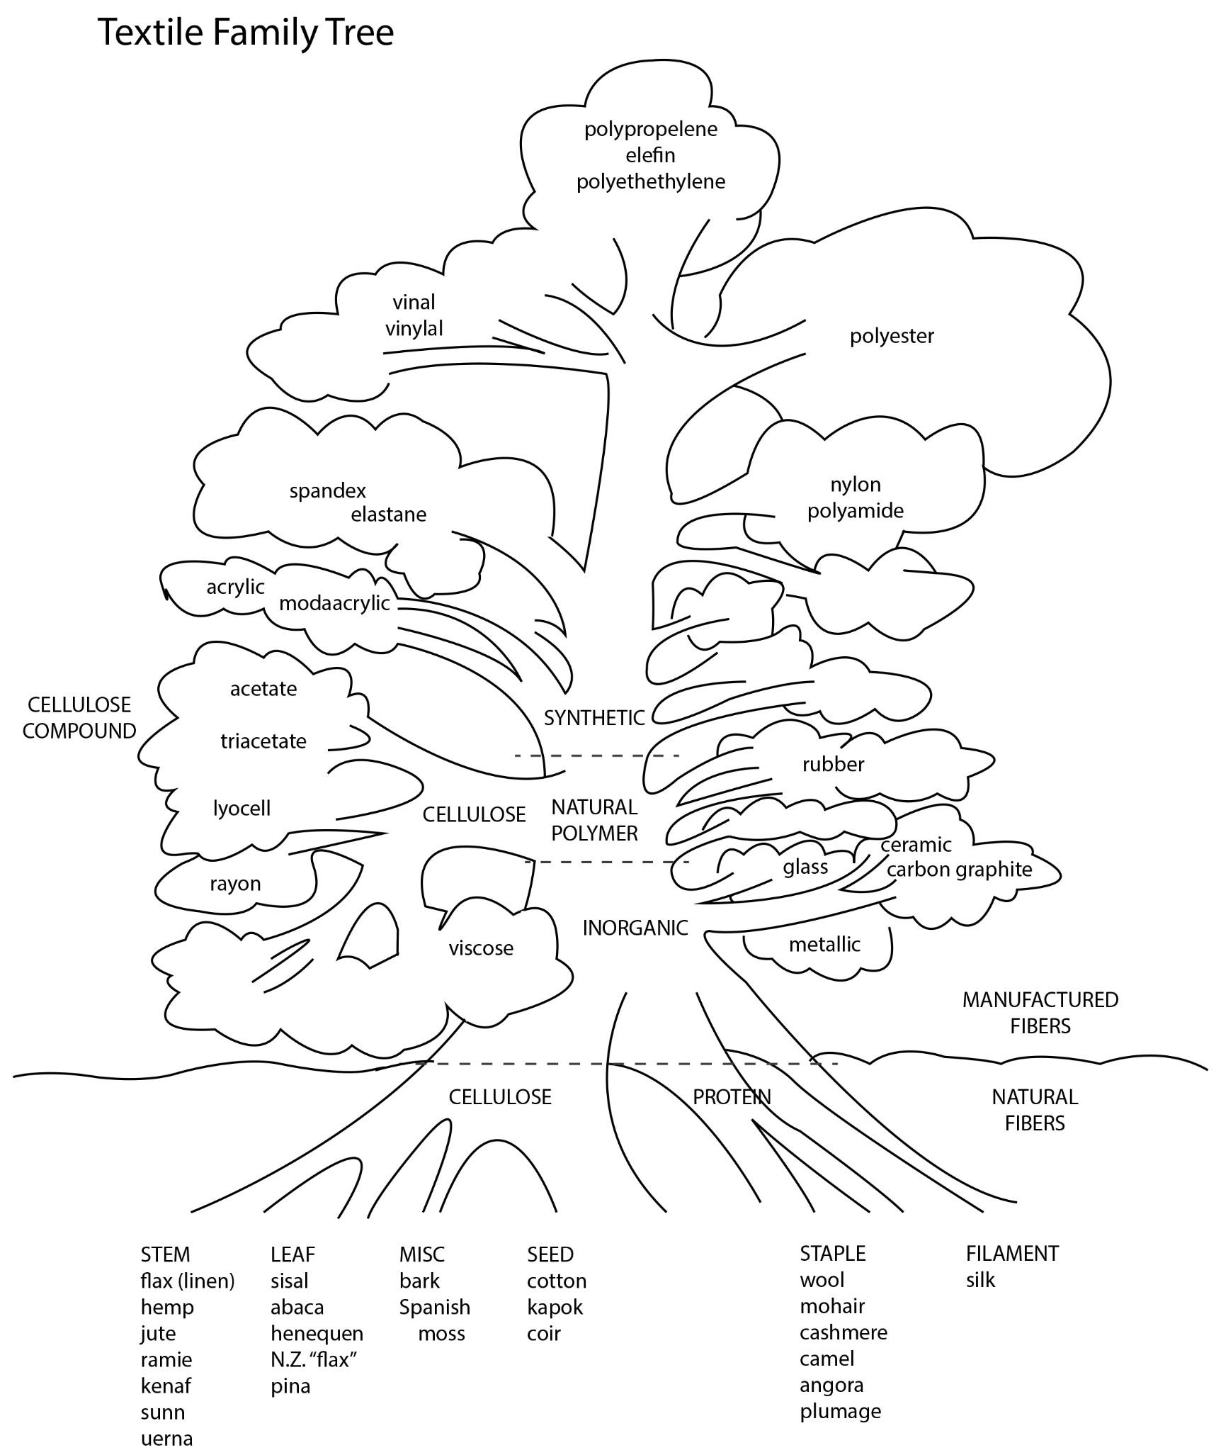
Source: Humphries, Mary. Fabric Reference. 3rd ed. Upper Saddle River, JJ: Pearson/Prentice Hall, 2004. Print.

