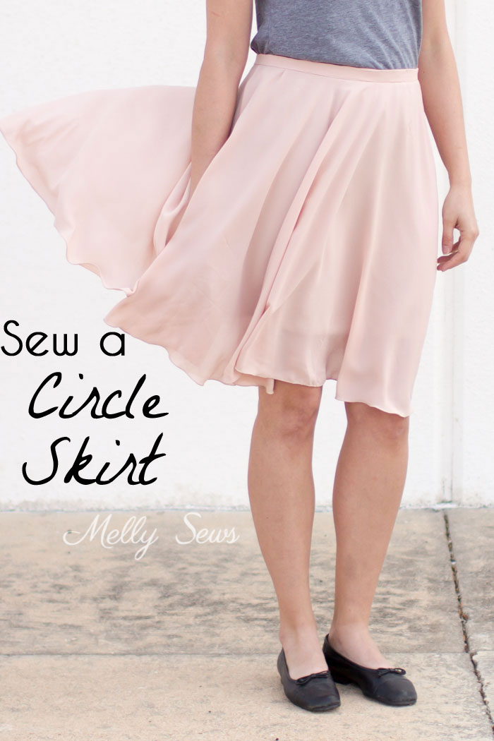
To make this skirt, you’ll need
- 1 3/4 yards of 60 inch wide fabric for an adult skirt that will be around 22-25 inches in length
- A 7-9 inch invisible zipper
- One sew on hook and eye closure
To start, you need to measure your waist where you want the skirt to sit. This doesn’t have to be at your natural waist. Choose the spot you feel is most flattering for you.
Then you need to do a little circle math—follow the diagram below.
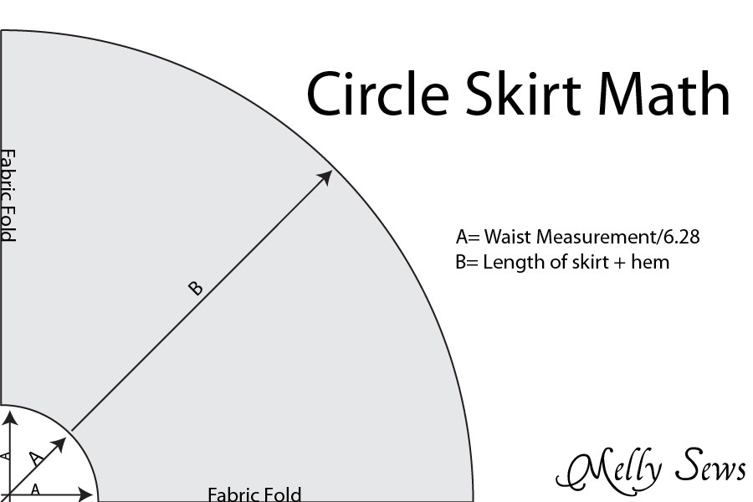

A suggestion—cut the skirt as long as you can. You’ll lose some when you event out the hem later.
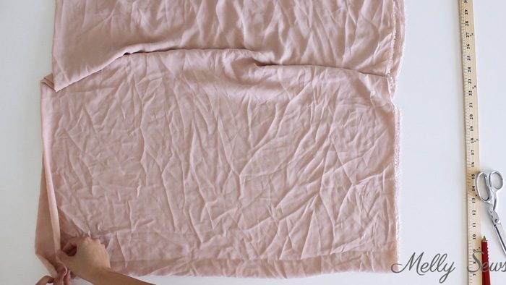
Fold your fabric so that the selvedges match, then fold the fabric again on the crossgrain. Working from the corner that has four folds and no raw edges, mark out a quarter circle that is your waist circumference divided by 6.28. Round that number down to the nearest 1/8 inch, because circles have bias areas and tend to stretch, so if you go up your skirt will be too big. Then measure from the waist marking out in another quarter circle to mark the hem of the skirt.

Cut your skit on both marks, and unfold to find a big donut. Note: if you want a longer skirt, or you’re working with a narrower width fabric, you can cut two half circles and seam them together on the edges.
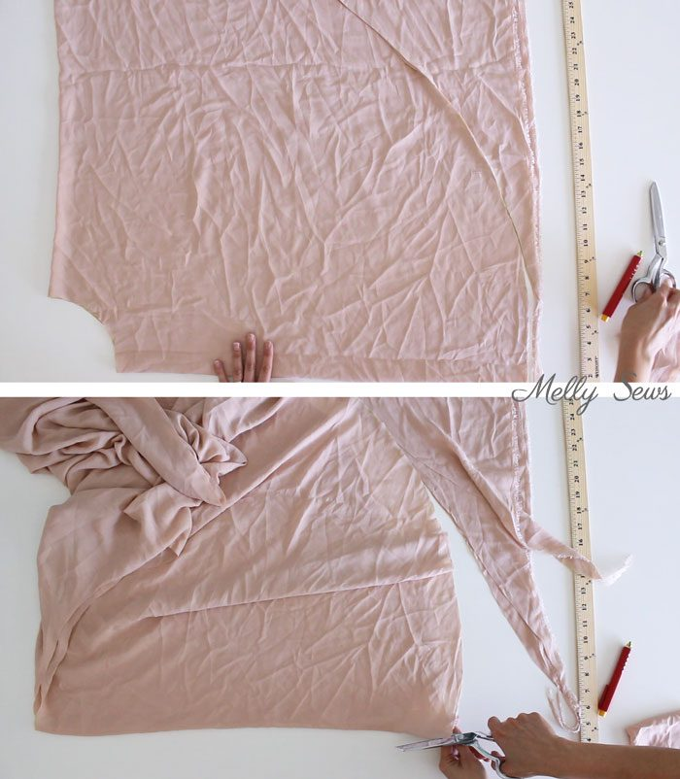
Next, with your skirt folded into a half circle on the straight or cross grain, cut open one edge so that we can create a seam and add a zipper to it.
Cut a waistband that is at least one inch longer than your waist measurement and 2 ½ inches wide. You want it that long so that you have ½ inch overhang at each end of the skirt. Prep the waistband by folding in half, wrong sides together and matching the long edges. Press, making a crease mark. Cut a ¾ inch wide strip of fusible interfacing and fuse it onto one side of the waistband, lined up with the crease mark on the wrong side. Finally, press the raw edge of the non-interfaced side of the waistband ½ inch to the wrong side.
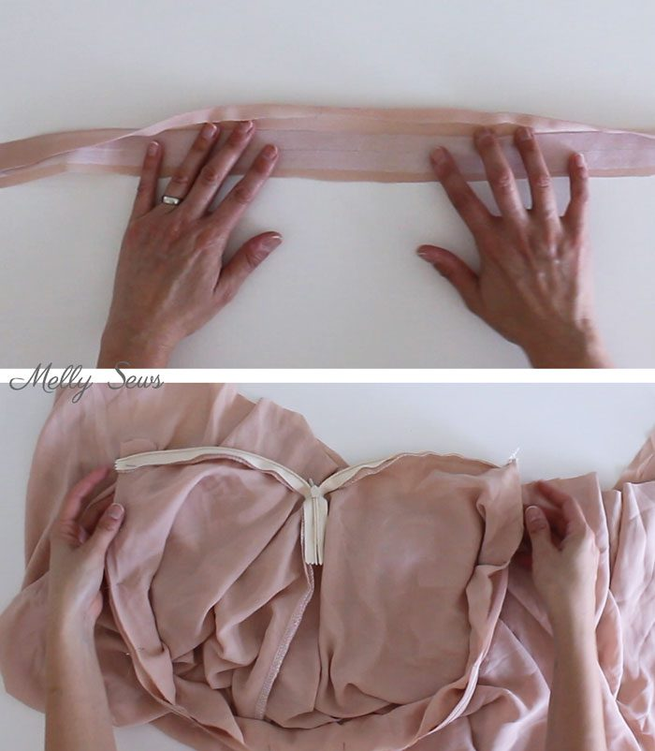
Follow the separate tutorial to install an invisible zipper and insert the zipper at the top of the seam.
Unzip the zipper, the attach the interfaced side of the waistband to the skirt with ½ inch hanging beyond the skirt on each edge, pinning right sides together. If your skirt has stretched and is longer that the waistband, sew a gather stich around the top to gather it very slightly to fit the waistband.
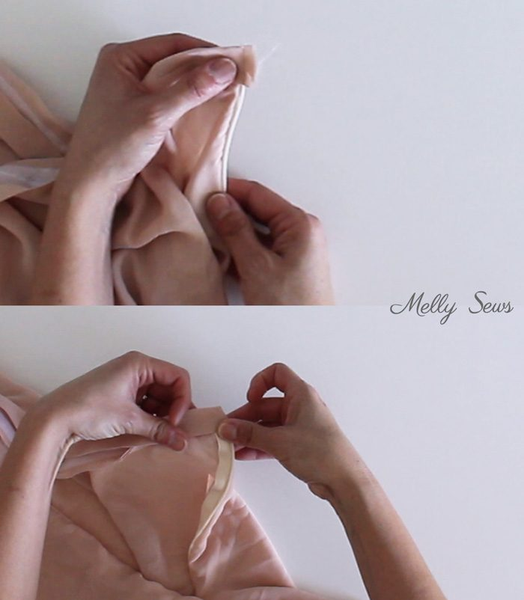
Fold the waistband right sides together on each end, and stich across the short end next to the zipper. Turn band right side out, and then press the seam allowances up. Fold the inner part of the waistband over the seam, then stitch in the ditch on the right side to secure the waistband.
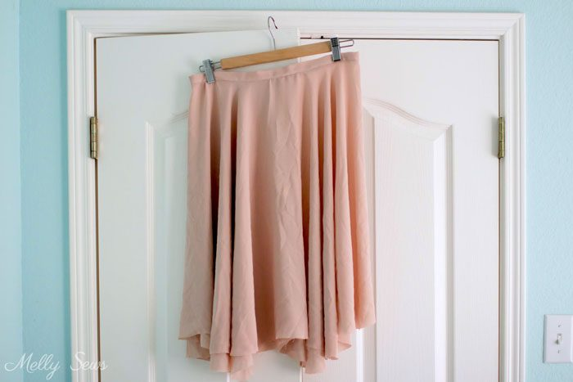

Because parts of a circle skirt hand on the bias grain it’s a good idea to hang the skirt overnight before hemming to make sure you can get an even hem. When pick the skirt back up later, you’ll need to trim the hem even. If you have a friend that can help you mark the hem, that’s ideal, but if don’t, this trick can work.
Finally, sew a rolled hem on the skirt to finish it and you’re done!
To sew a rolled hem, set your machine to the widest zig-zag it will do and a very short stich length.
Press your edge 1/8 inch to the wrong side all around. Move the needle as far to the right as it will go (7.0). Put the needle down with the hand crank. Place the folded edge of the fabric against the needle and lower the foot.
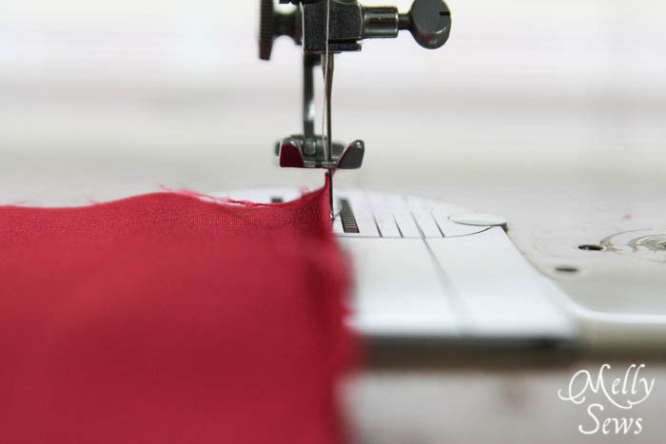
Stich over the edge with one side of the zig-zag landing over the edge. This will wrap the edge of the fabric in thread and create a rolled hem, which looks like this:
Alternately, if you have a hemming foot, set your machine with the same type of zig-zag, but skip the pressing. Instead, just feed the fabric through the foot and let it do the rolling for you as you stitch.
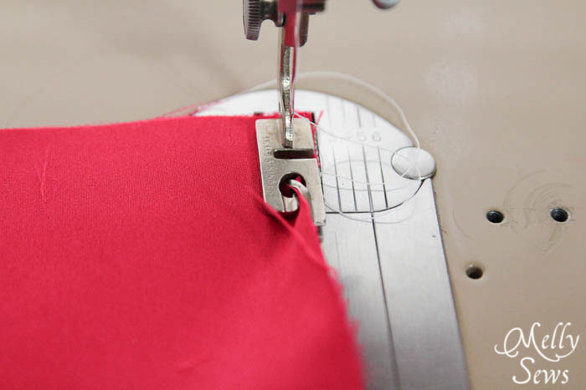
You can also use the serger for this seam, but you are limited in thread color.

