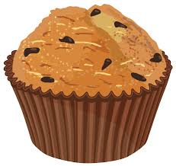
Muffins… how, what, why???

Have you ever wondered about the purpose of each of the ingredients in muffins and the importance of each step of the procedure? We are going to conduct experiments to find out what the purpose is and how important each step is.
Variables include: Ingredient type and amounts, temperature, agitation, time, procedure changes etc.
This is an individual project
TASK:
- Find and turn in a muffin recipe, reduce yield to make 6-8 muffins.
- Identify your variable and experiment: Look at the examples given and identify your aim and experiment procedure. Confirm this with me (Mrs Debelle)
- Neatly type up Lab. Part a, b and c due Tuesday 21st; Part d and e due same day as experiment.
  - Title
  - Aim
  - Procedure, include ingredients and method
  - Data/Results, this could be in the form of a table and/or graph
  - Conclusion
- Conduct Lab experiment during finals week, Wednesday 22nd January
RUBRIC:
Recipe /5
Chosen Variable /3
Write up
  - Title /2
  - Aim /5
  - Procedure /20
  - Data/Results /20
  - Conclusion /20
Experiment /25
TOTAL /100

For example, why is baking powder used in some muffin recipes? How does the baking powder affect how the muffins look, feel, and taste? Why do we use baking powder not baking soda? How does mixing affect the texture? Which flour types is best? How important is the use of a whole egg in the recipe? etc.

