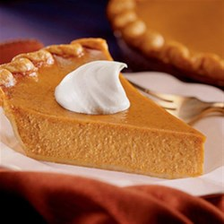
Pumpkin pies

Shortcrust pastry (per pair)

1 cup plain flour
85g butter
2 tbsp icing sugar
½ egg yolk
1 ½ tbsp milk

- Sift the flour into a bowl.
- Rub in the butter with your fingertips until the mixture resembles fine breadcrumbs.
- Sift the icing sugar into bowl with flour and butter and stir through.
- Mix egg yolk and milk together with a fork and add to dry ingredients.
- Kneed briefly in on a lightly floured work surface.
- Wrap in Clingfilm and chill in the refrigerator.

Pumpkin filling (per pair)

3/4 cup white sugar
1 teaspoon ground cinnamon
1/2 teaspoon salt
1/2 teaspoon ground ginger
1/4 teaspoon ground cloves
2 eggs
½ (15 oz) can LIBBY'S(R) 100% Pure Pumpkin
1 (12 fluid ounce) can NESTLE(R) CARNATION(R) Evaporated Milk

Directions
- Preheat oven to 425 degrees F.
- Cut pastry in half
- Roll out your own pastry to 5mm thick. Then use it to line the tin.
- Combine sugar, salt, cinnamon, ginger and cloves in small bowl. Beat eggs lightly in large bowl. Stir in pumpkin and sugar-spice mixture. Gradually stir in evaporated milk. Pour into pie shell.
- Bake for 15 minutes. Reduce temperature to 350 degrees F.; bake for 40 to 50 minutes or until knife inserted near centre comes out clean. Cool on wire rack for 2 hours. Serve immediately or refrigerate. (Do not freeze as this will cause the crust to separate from the filling.)

