Zippers Unzipped- How to Sew a Zipper
46.2K
May 10, 2013 by Melissa Mora 22 Comments
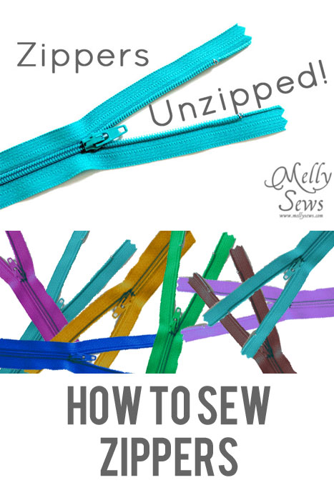
Hey y’all – today we’re going to talk zippers- specifically how to sew a zipper in. I know many new to sewing are scared of zippers and buttons, but there’s really nothing to be scared of, and being able to sew closures vastly expands the types of things you can sew. From floor pillows to dresses to zip flys, sew a zipper and you’re on your way.
This video is the short version of what we’re going to do.
How to Sew a Zipper

Tools:
Two tools I find indispensable for zipper installation are my seam ripper and Scotch tape. Surprised? Keep reading.
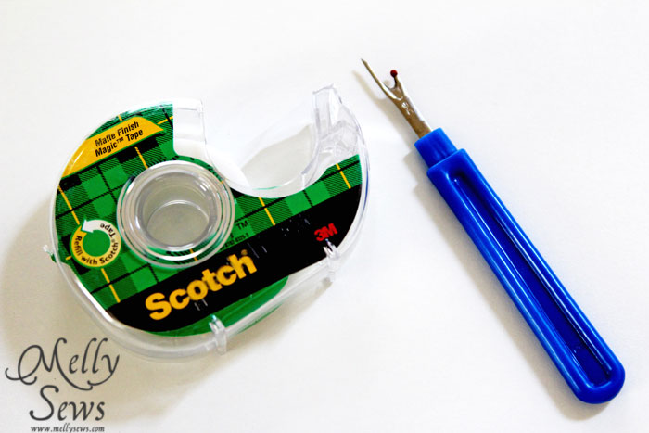
You’ll also need a zipper foot for your machine. Most new machines come with one – the zipper foot is on the right in the picture below, and the regular foot is on the left. You’ll notice that instead of two “toes” it only has one, and it has a slider so that you can position the needle on either side of the foot. This is so that you can have the needle stitching right next to the zipper teeth without the foot getting in the way.
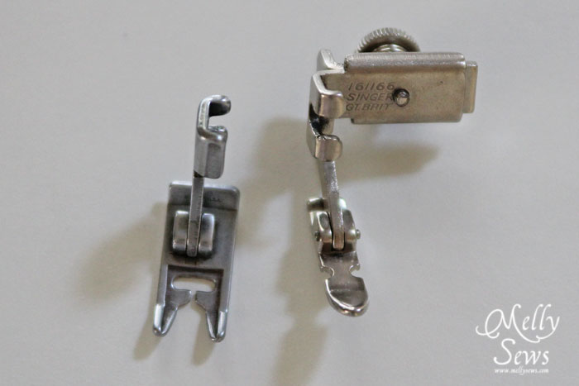
On Seam Application
This is how I install my zippers 90% of the time. Start by sewing the seam you’re going to put the zipper in with a basting stitch. Backstitch at the bottom of the zipper length, and then continue stitching the seam with a regular stitch length.

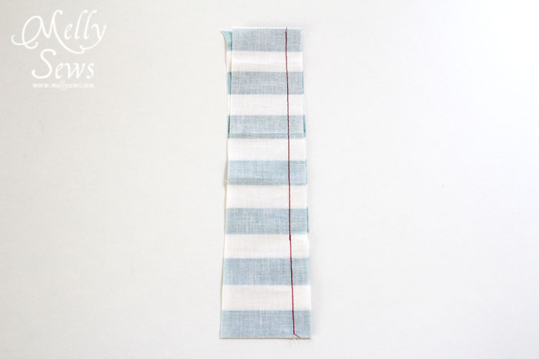
Press your seam open flat.
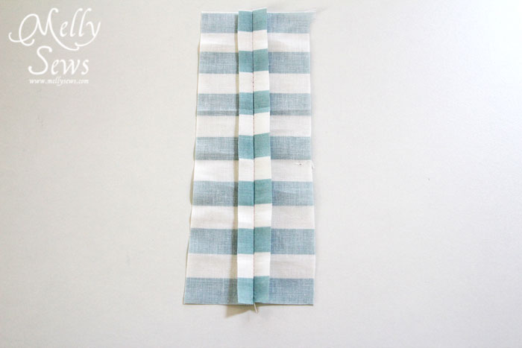
Lay the zipper face down over the seam, lining the teeth up with the seamline.
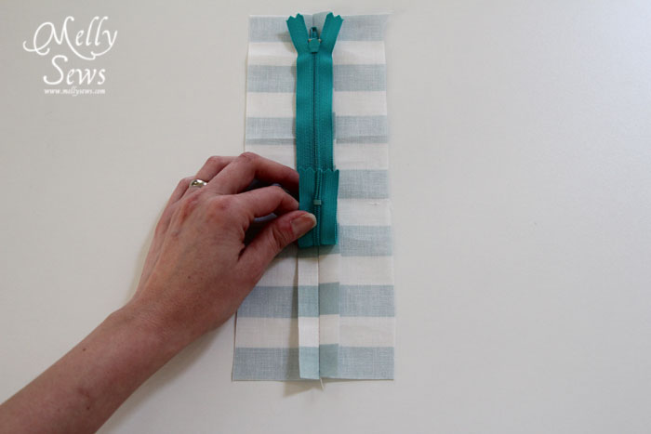
Use a few pieces of scotch tape (no more than 1 every 4 inches or so) to hold the zipper in place.
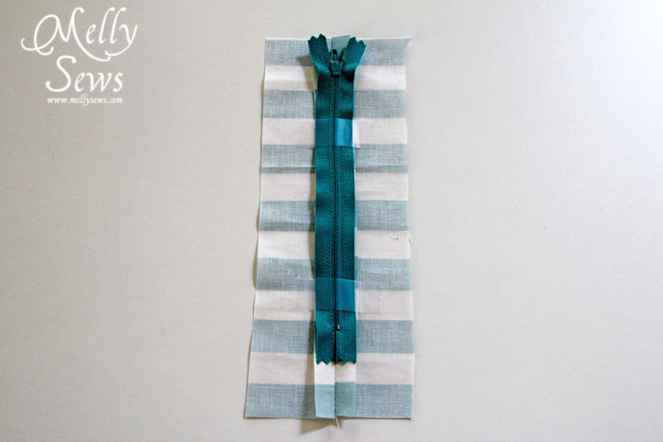
Carefully turn your fabric right side up and stitch 1/4″ away from the seam down one side, stop with the needle in, turn, stitch across the bottom of the zipper just above the zipper stop (you may want to mark this with a pin) and then stop and pivot again, then sew up the other side. Don’t worry about the top part of the zipper where the pull makes it hard to keep your stitching straight – we’ll get to that in a minute.
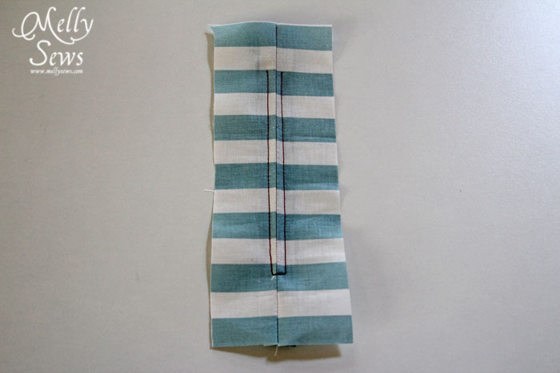
Remove your tape.
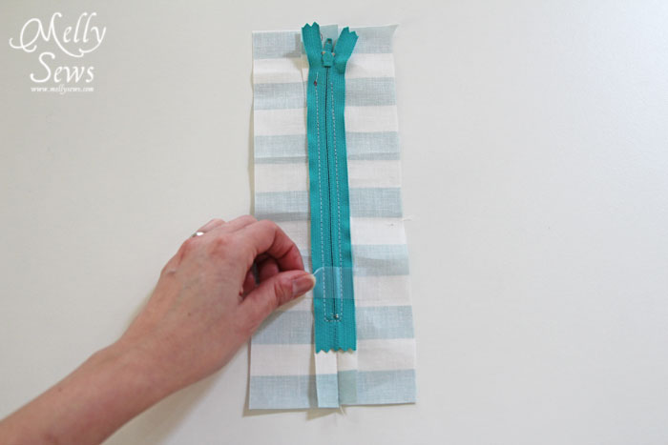
Use your seam ripper to remove the basting stitches.

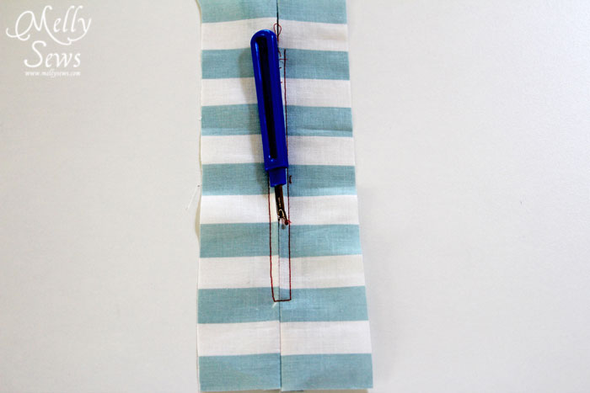
Unzip your zipper and pin the top part of the zipper tape to the fabric, keeping the seams folded under.
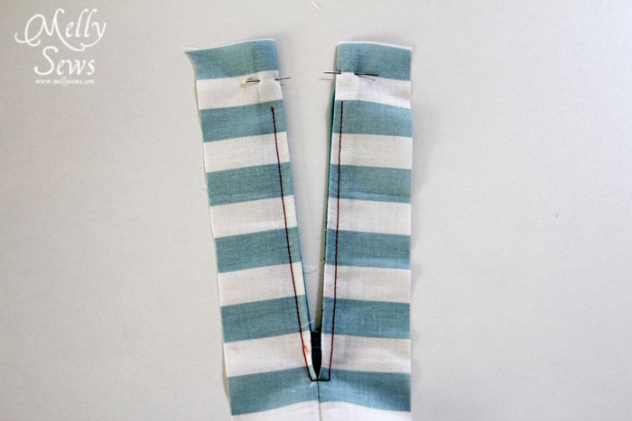
Stitch the top part of the zipper to the fabric.
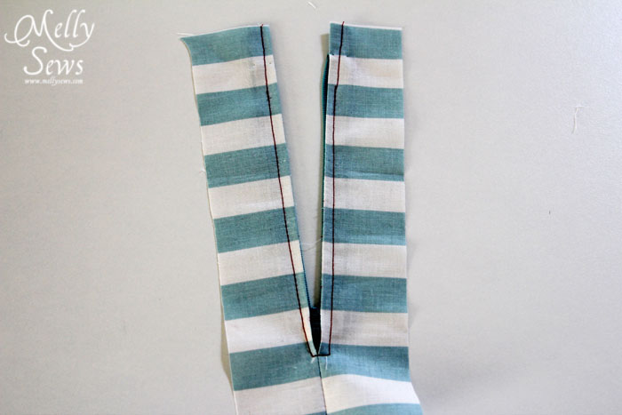
You’re done! That wasn’t so hard, was it? Front side:
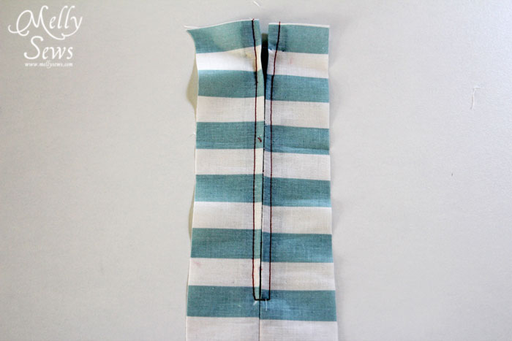
Back side:
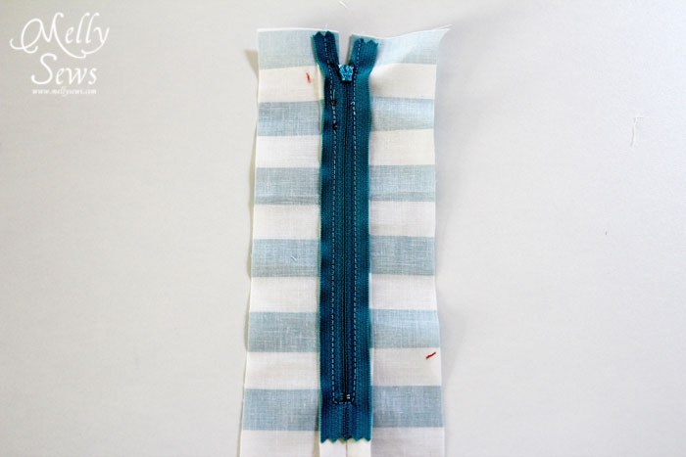
Lapped Application
If you want to get all fancy, then you can do a lapped application. Warning – this won’t work with less than a 5/8″ seam allowance.
Sew your seam as you did for the on seam application, basting, backstitching, then regular stitch length below the zipper. Then press one seam allowance out and the other flat, as shown below.
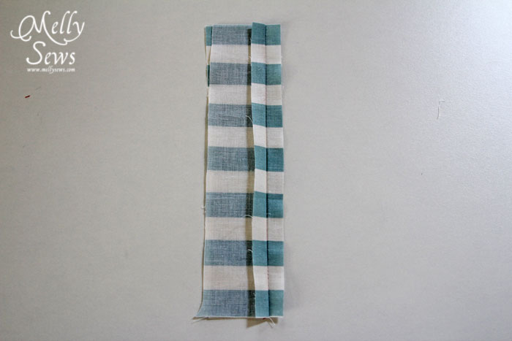
Lay your zipper face down, with the teeth just to the right of the seam line. Stitch the zipper tape to the seam allowance that’s sticking out – on the right in the picture below. This is just a basting stitch and won’t be seen later, so it’s OK to curve your stitching around the zipper pull.
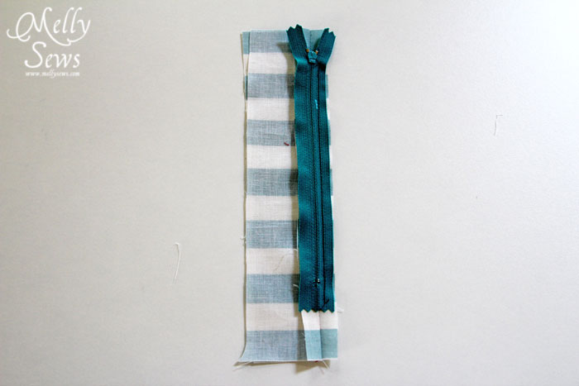
Tuck the zipper under, so it is face up and the seam allowance folds right next to the teeth. Stitch the seam allowance and zipper tape together right next to the teeth. If you need to, you can unzip the zipper to sew the part next to the pull, then stop with your needle down and zip up the zipper (you may have to raise the foot to do this) then continue stitching.
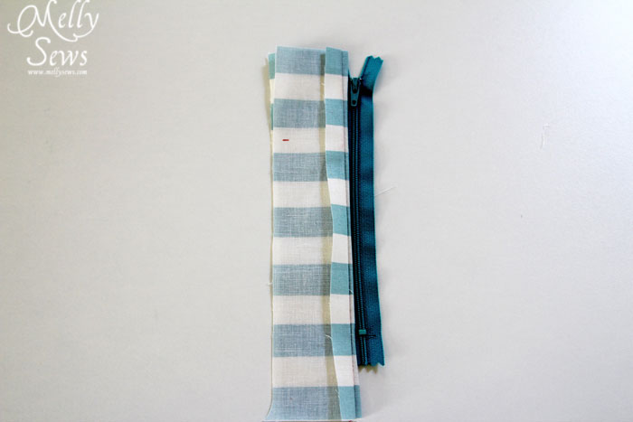

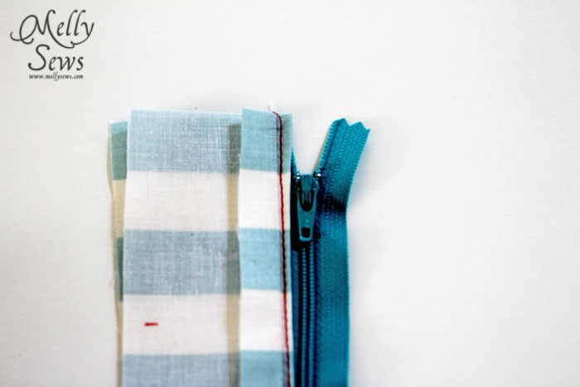
Press the seam flat. With right side up, sew down the unsewn edge of the zipper, securing it to the fabric and other seam allowance, then pivot and stitch to the seamline. Backstitch here.
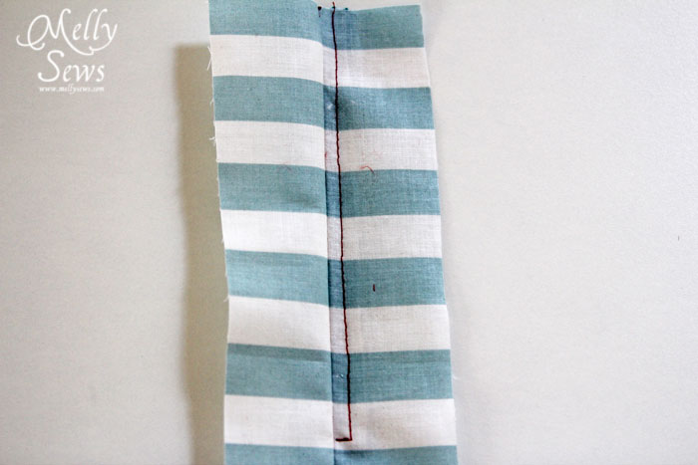
Remove basting stitches and reveal your lapped zipper!
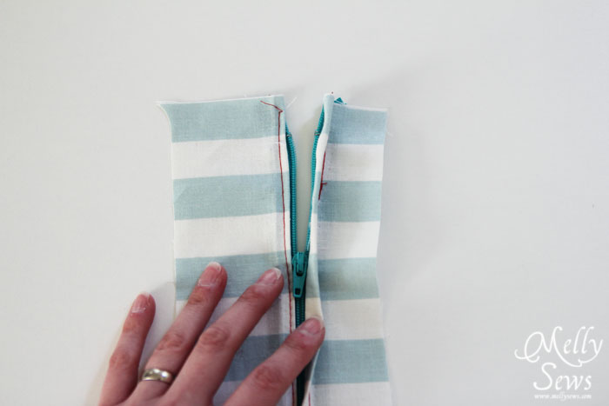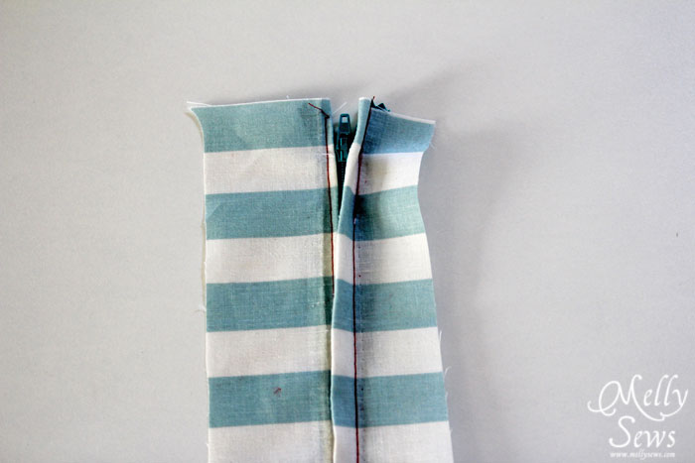
Happy sewing,

